Using Mite via Microsoft Flow

You can access information from mite via Flow and generate task with it. For example, get the information of all customers and send it to your inbox.

# How to Setup

First direct to the website: flow.microsoft.com, in a browser of your choice.  
After you logged in click on the gear-icon in the righthand corner and select “Custom Connectors”.

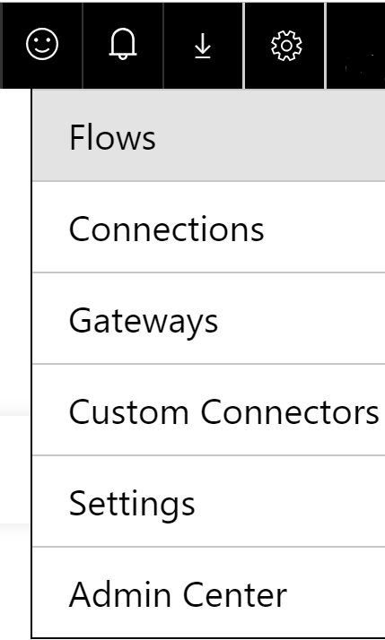

Next you must create a new custom connector. For that select “import an OpenAPI file”. The file can be downloaded from https://github.com/MarcoBrightSkies/miteSwagger. Name it as you like and select the .json-file you downloaded.

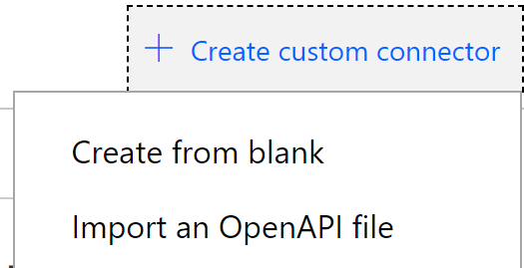

Create the Connector by clicking on the “Create connector”-button on the top right.

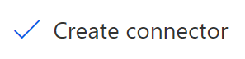

*The process of creating the connector can take some time before it works fully. I would suggest waiting approximately 30 minutes before testing!*

# Creating a Flow

After you created the Custom connector you can create a flow with it. For this click on the gear-icon in the righthand corner and select “Flows”. Create a new flow by clicking on “Create from blank”.



At first you must choose a trigger. I will take a manual button for this example.

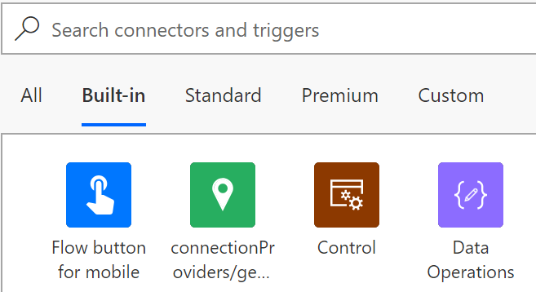

Crete a new step and select the custom connector you create before.



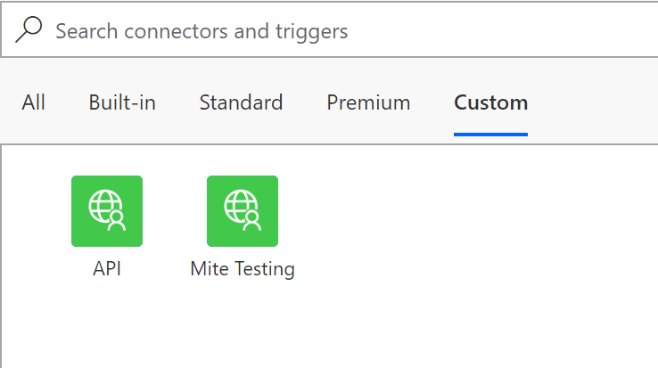

Now select the action you would like to start when the trigger is initiated. For this example, I choose “GetCustomers” to get information about the customers.

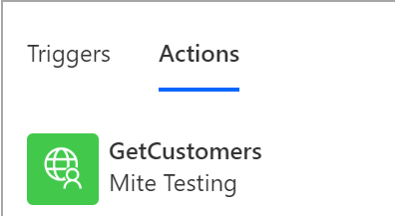

Next, I add a new step and select an action I want to run with the information I got from “GetCustomer”. In this case I want to send an email with the customer name and ID for all customers I have.



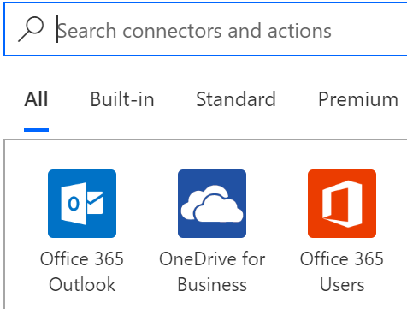

This is how the action should look like:

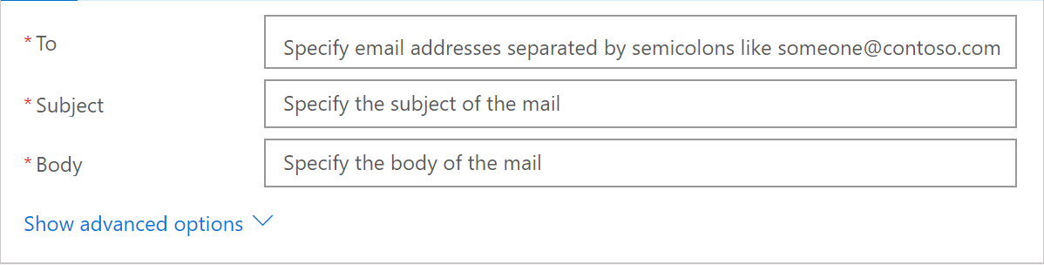

If you now click inside the “Body” a new window will appear, where you can select “dynamic content”. Here you can select the information you collect from “GetCustomer”. Press on “See more” to see all the information you can select.

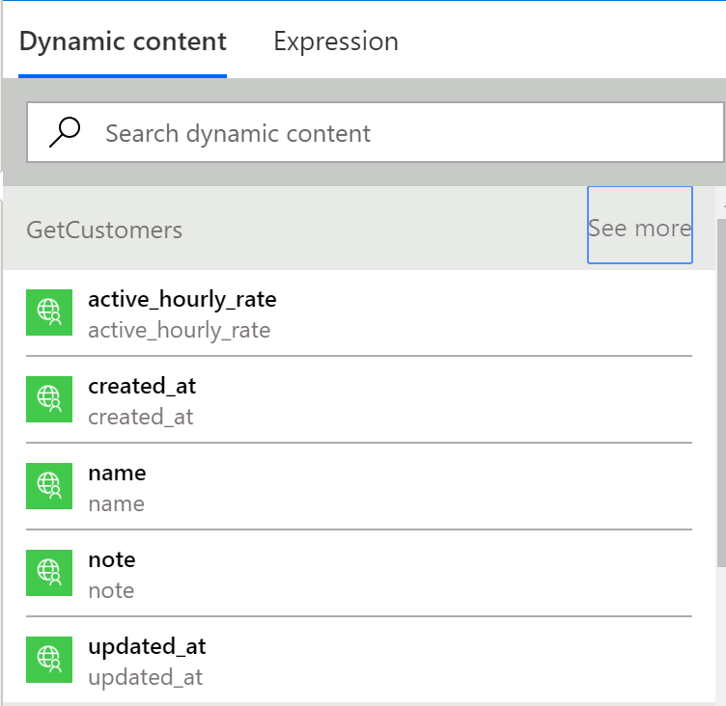

An example of an email with the Customer name and ID would look like this:  
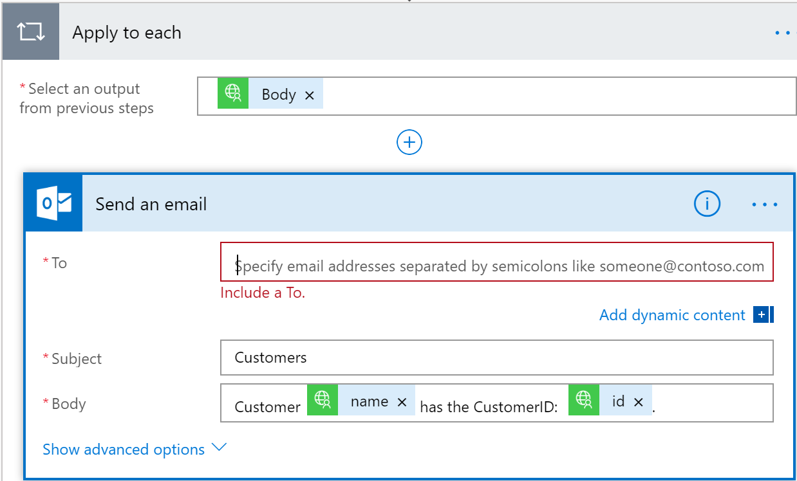

This will send an email for every customer with his name and ID. For example:  
If I had two customers

Jane Doe & John Doe with the ID’s 123456 & 654321 the output would be two emails:  
Subject: Customer  
Body: Customer John Doe has the CustomerID:123456.

Subject: Customer  
Customer Jane Doe has the CustomerID:654321.

The final Flow for this example should look like this:

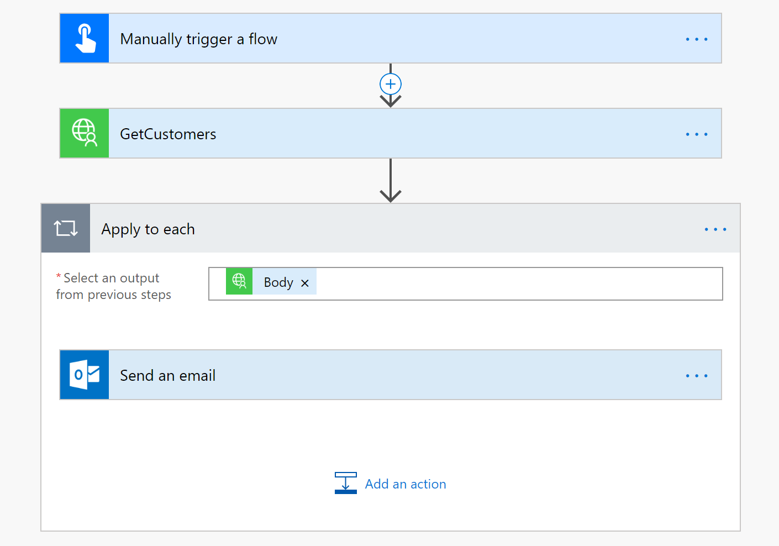

You can test your flow at any given time by using the test function from flow via the button in the righthand corner.

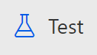

When the test was successful it should look like this:

